Python Module End Assignment : Survey Feedback Analyzer
Date of Submission : 16 - 10 - 2026
Name : K.Sreelatha

Screen shot:

Step 1: Preloaded Feedbacks (Given Data)

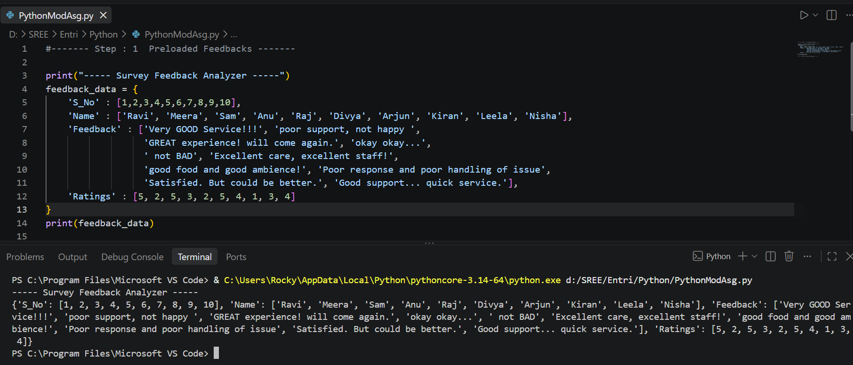

Step 2: Add More Feedbacks

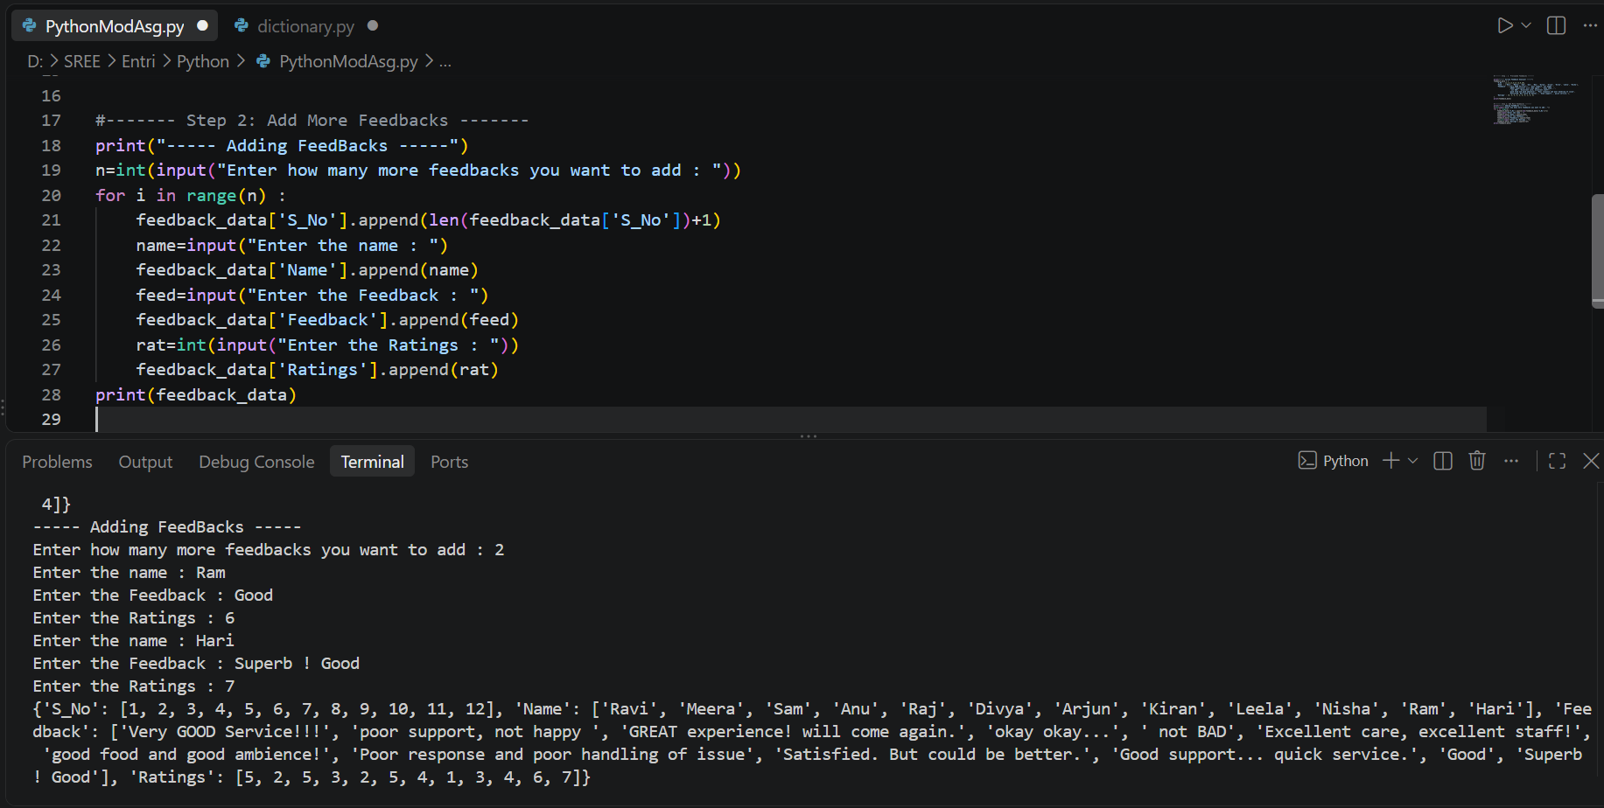

Step 3: Text Cleaning

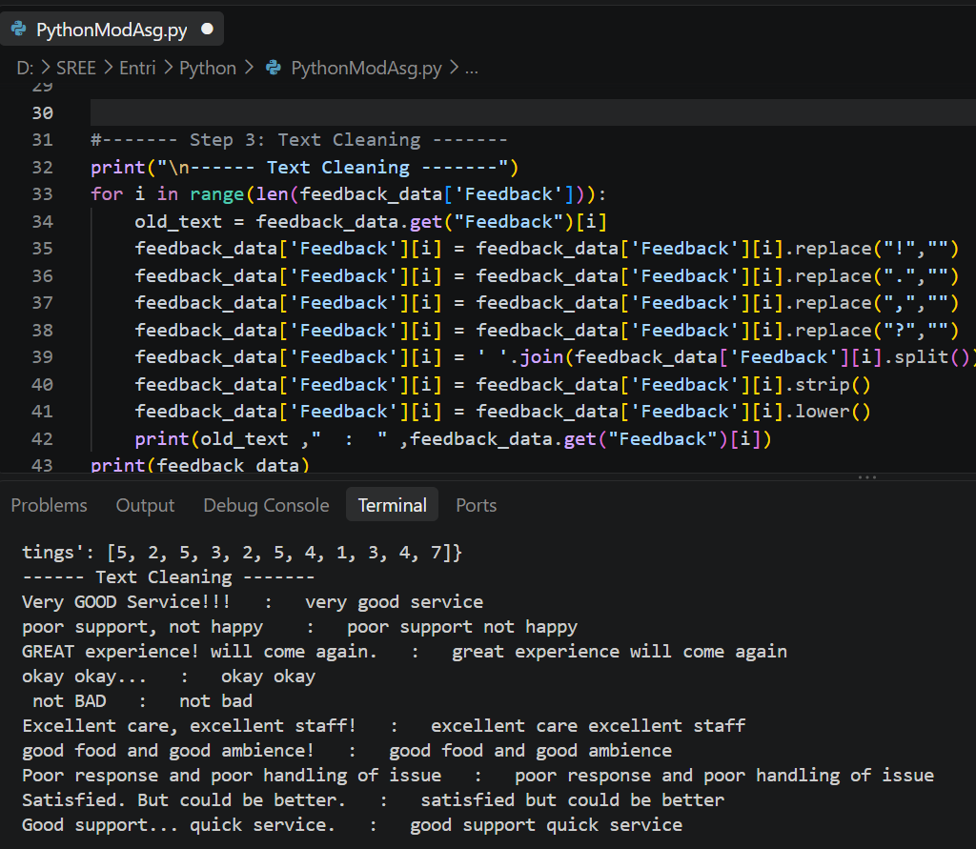
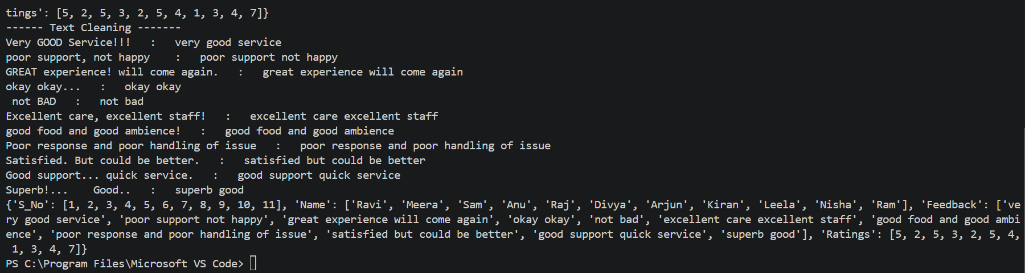
Step 4: Word Count Insights

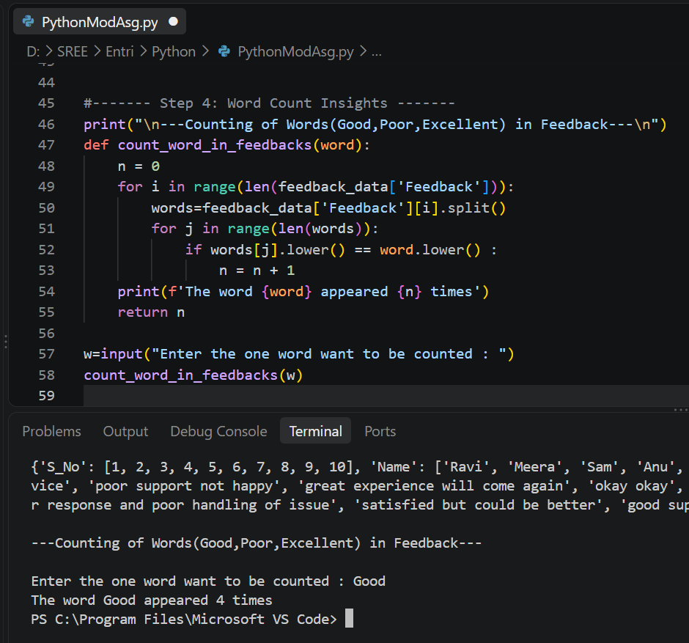

Step 5: Final Summary & Insights

Display the final cleaned feedback_data (dictionary of lists)

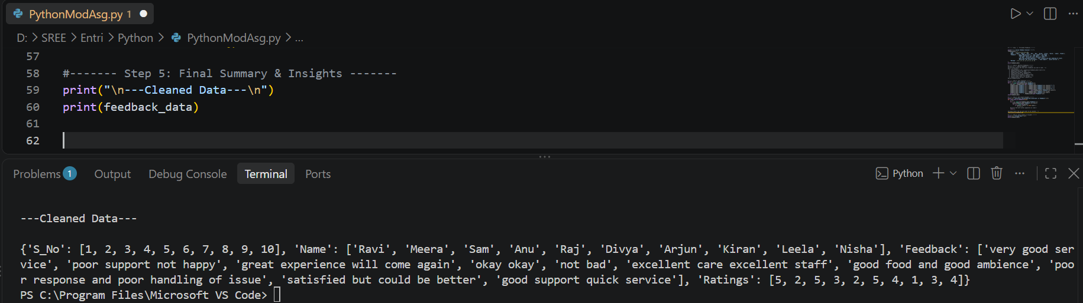

Print the average rating from all feedbacks

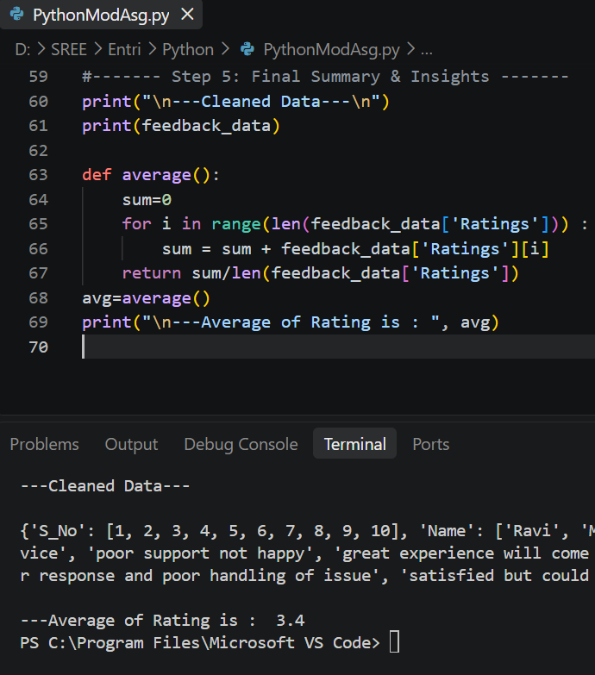

Find and display the feedback with the longest comment (in terms of word count)

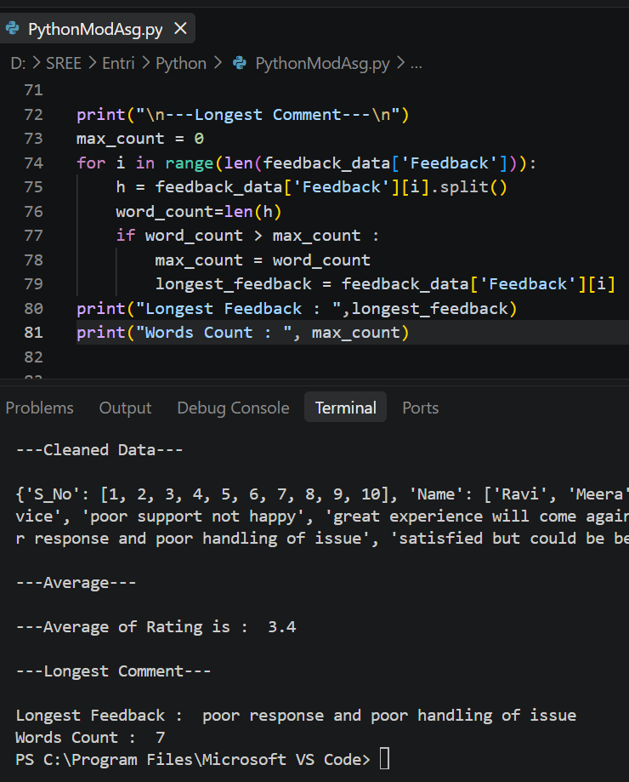

Print the list of unique words used across all feedbacks (avoid duplicates)
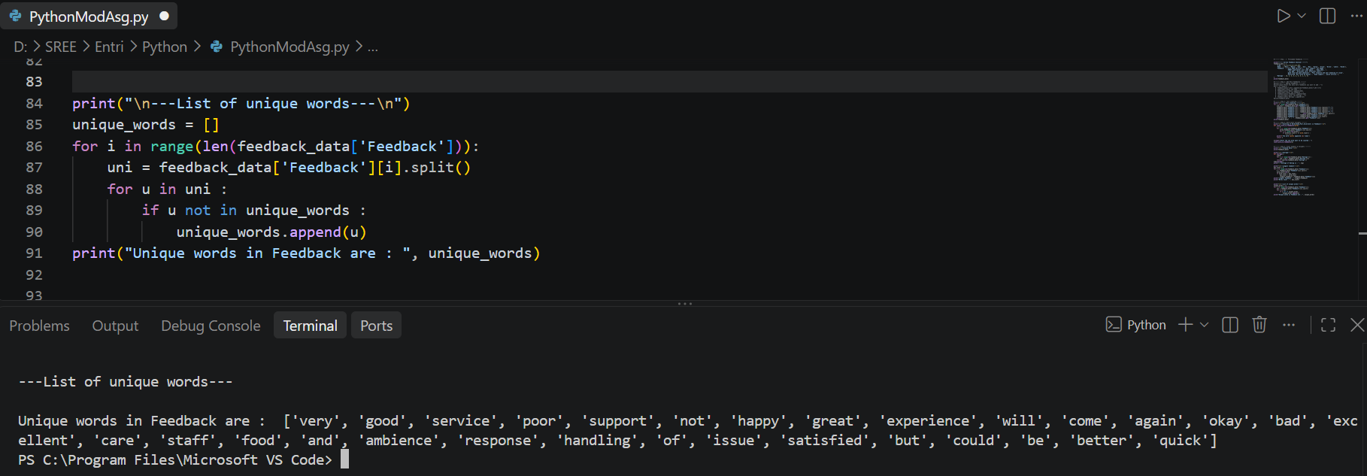

Sort feedbacks by rating (highest to lowest) using zip() and sorted(). Display the sorted entries
